**LAB5: Configuring AWS CNI (Container Network**

**Interface) for EKS**

**\*\*Tasks**:**

**- Set up EKS with a custom VPC.**

**- Configure custom networking with AWS**

**CNI.**

**- Test and validate.**

**- **Documentation**: Describe AWS CNI**

**and its significance in EKS.**

**Prerequisites:**

**Install kubectl**

**Install eks**

**Install awscli**

**Add access key**

**Add roles for cluster and node permissions**

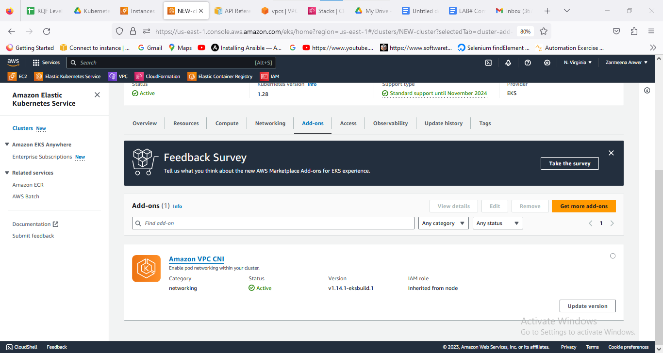

| **kubectl get pods -n kube-system** |
| --- |

| **kubectl get nodes -o wide** |
| --- |

**kubectl get pods -n kube-system -l k8s-app=aws-node**

**Documentation of the lab:** Understanding AWS CNI (Container Network Interface) AWS CNI Overview:

* + Native Networking Plugin: AWS CNI is the default networking plugin for Amazon EKS, providing networking capabilities for pods running on AWS.
  + Amazon VPC Integration: It leverages the networking features of Amazon VPC to provide networking and IP addressing for pods.
* Networking Features:
  + Elastic Network Interface (ENI): AWS CNI assigns an ENI to each Kubernetes pod, enabling direct integration with VPC networking and utilizing AWS security features.
  + IP Address Management: It manages IP address assignment and allocation for pods, ensuring efficient utilization of available IP addresses within the VPC.
* Network Isolation and Security:
  + VPC-Level Isolation: Pods running on EKS are isolated at the VPC level, providing security and isolation within the AWS infrastructure.
  + Integration with AWS Security Groups: AWS CNI integrates with AWS Security Groups, allowing fine-grained control over inbound and outbound traffic to pods.

**Conclusion of the lab:**

**AWS CNI serves as a crucial networking component in Amazon EKS, playing a pivotal role in providing networking capabilities to Kubernetes pods and ensuring secure, scalable, and efficient communication within the EKS cluster.**

* **Seamless VPC Integration: AWS CNI's tight integration with Amazon VPC leverages its robust networking features, enabling seamless communication and security features within the VPC.**
* **Enhanced Security and Isolation: Leveraging AWS Security Groups and VPC-level isolation, AWS CNI ensures that pods within the EKS cluster operate in a secure and isolated environment, mitigating potential risks.**
* **Scalability and Efficient IP Management: With ENIs allocated to each pod and efficient IP address management, AWS CNI optimizes IP utilization and scalability while maintaining control over networking resources.**

**The integration of AWS CNI within Amazon EKS simplifies networking configurations, enhances security, and ensures compatibility with native AWS networking features. It facilitates the creation of resilient and secure Kubernetes environments, aligning with best practices for cloud-native deployments.**

**Continuous monitoring, optimization, and adherence to networking best practices further enhance the performance, scalability, and security posture of Amazon EKS clusters leveraging AWS CNI.**